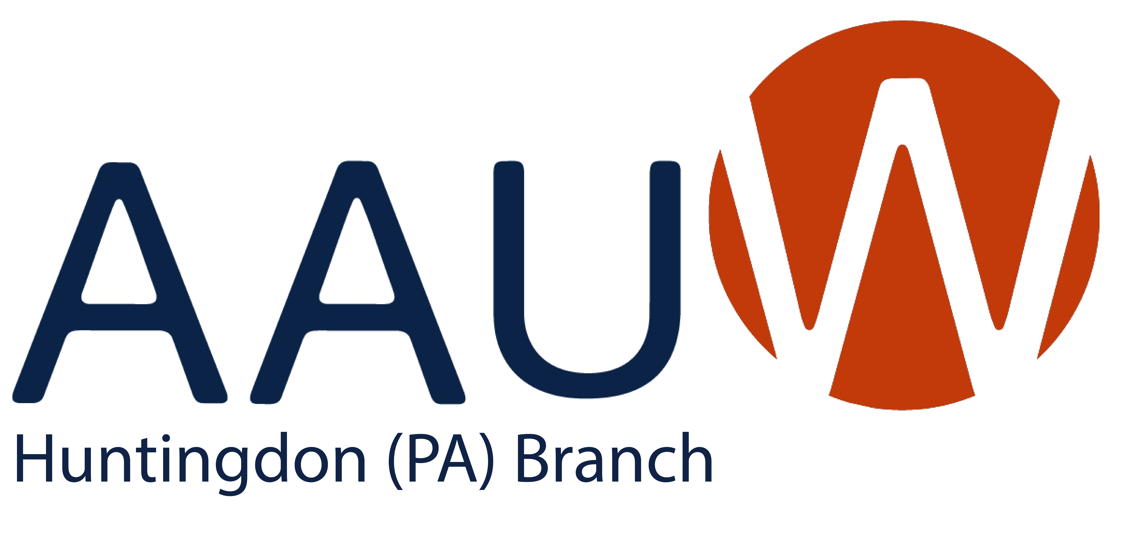

AAUW-Huntingdon Branch invites you to join us in work toward our mission of advancing equity for all women and girls through advocacy, education, philanthropy, and research.

To join or renew your membership, please complete the form below and submit it along with a check for annual dues of $91 ($72 for national dues, $12 for state dues, and $7 for branch dues) made out to AAUW-Huntingdon Branch to our finance officer, Charlotte Ridge, 271 Standing Stone Ave., Huntingdon, PA 16652, or give it to any other current AAUW member.

New members are welcome at any time.
DUES RENEWAL DEADLINE: June 30 or one year from when you joined.

Name: _______________________________________________Date: ____________________

Mailing address: ________________________________________________________________

Home phone: __________________________ Office phone: ____________________________

Cell phone: ______________________ Email address: _________________________________

Please list your first degree (Associate, Nursing, Bachelor) received after high school:

Degree: _________ Granting institution: ___________________________________________

Date: ___________ Major field of study: ___________________________________________

